1. CREATE DATABASE
2. CREATE CUSTOMER TABLE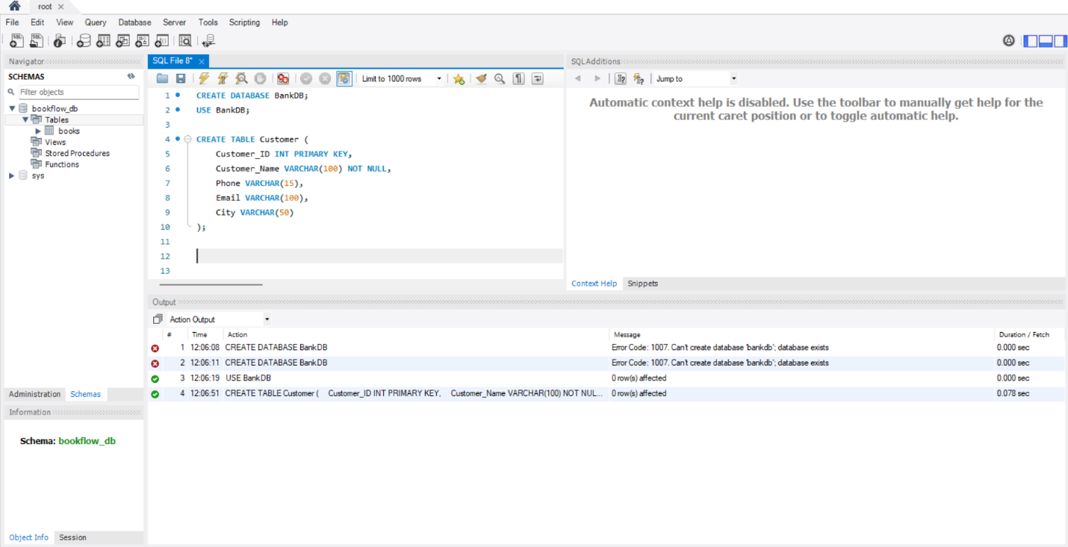3. CREATE ACCOUNT TABLE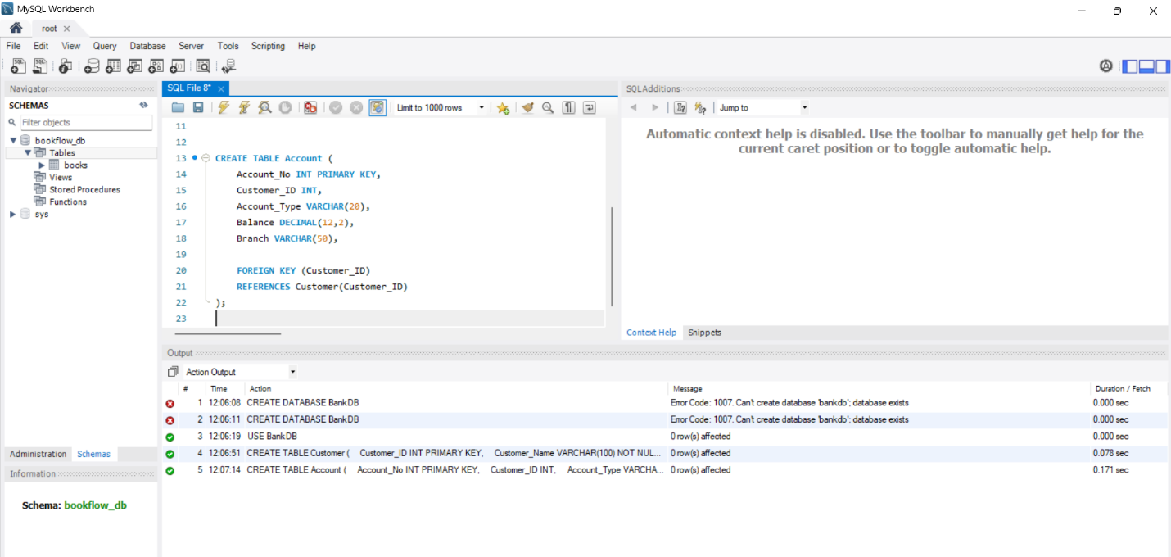4. CREATE BANK TRANSACTION TABLE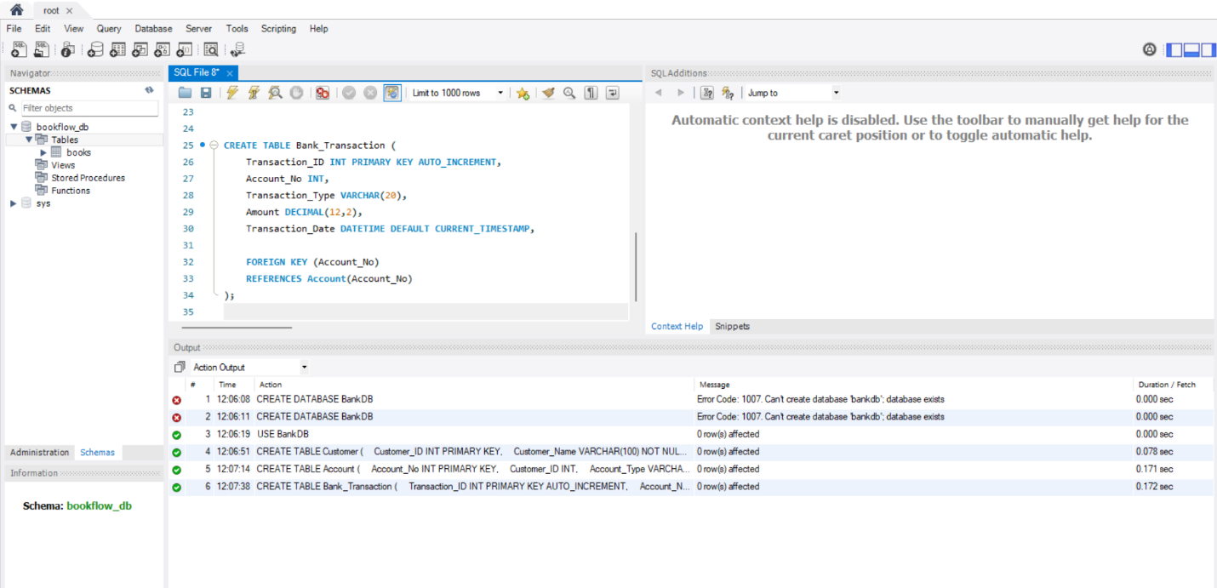5. CREATE LOAN TABLE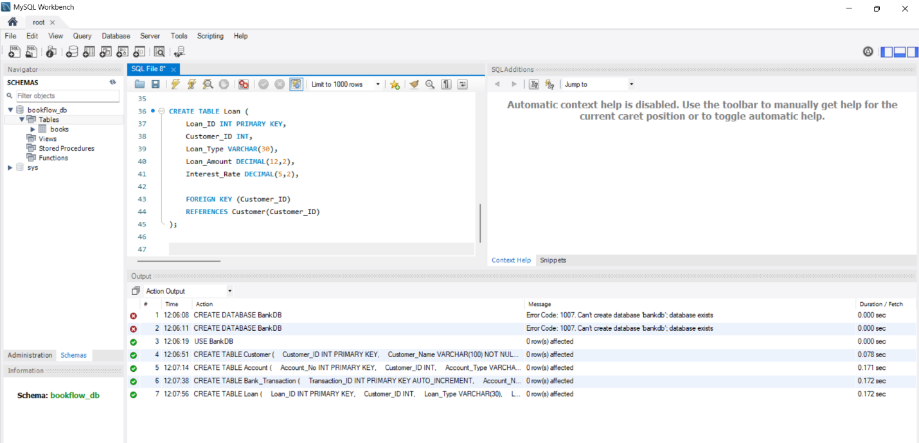6. INSERT CUSTOMER DATA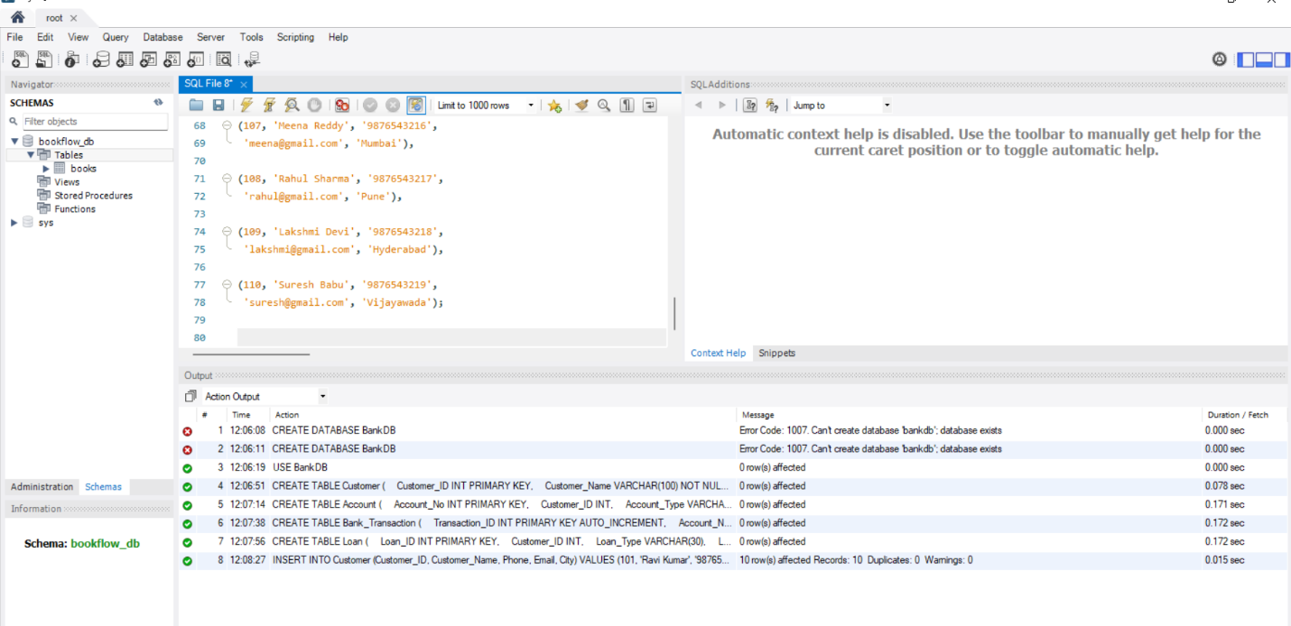7. INSERT ACCOUNT DATA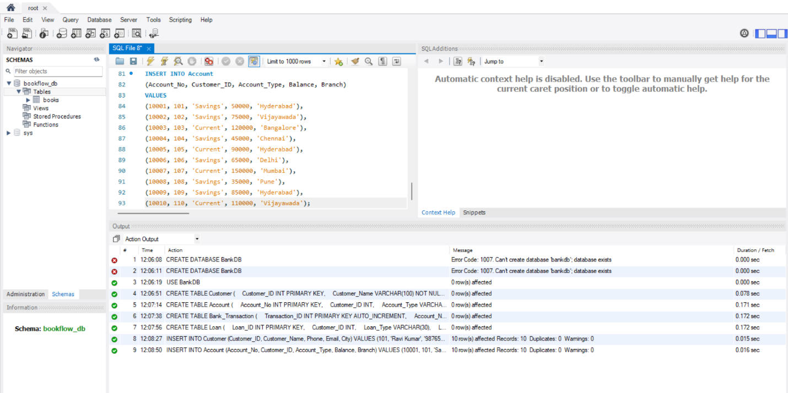8. INSERT TRANSACTION DATA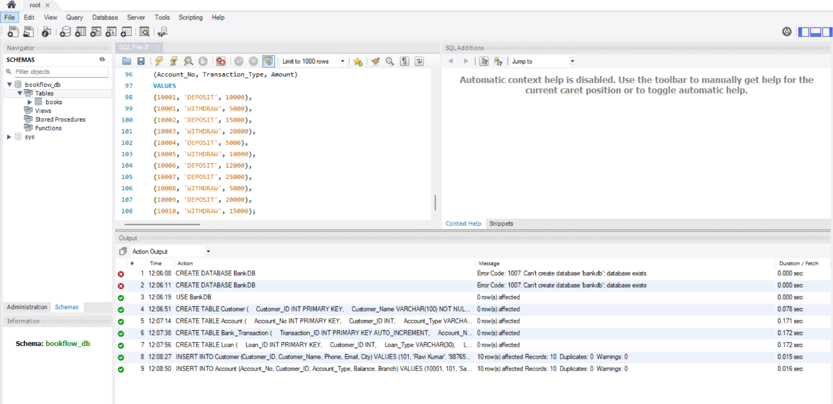9. INSERT LOAN DATA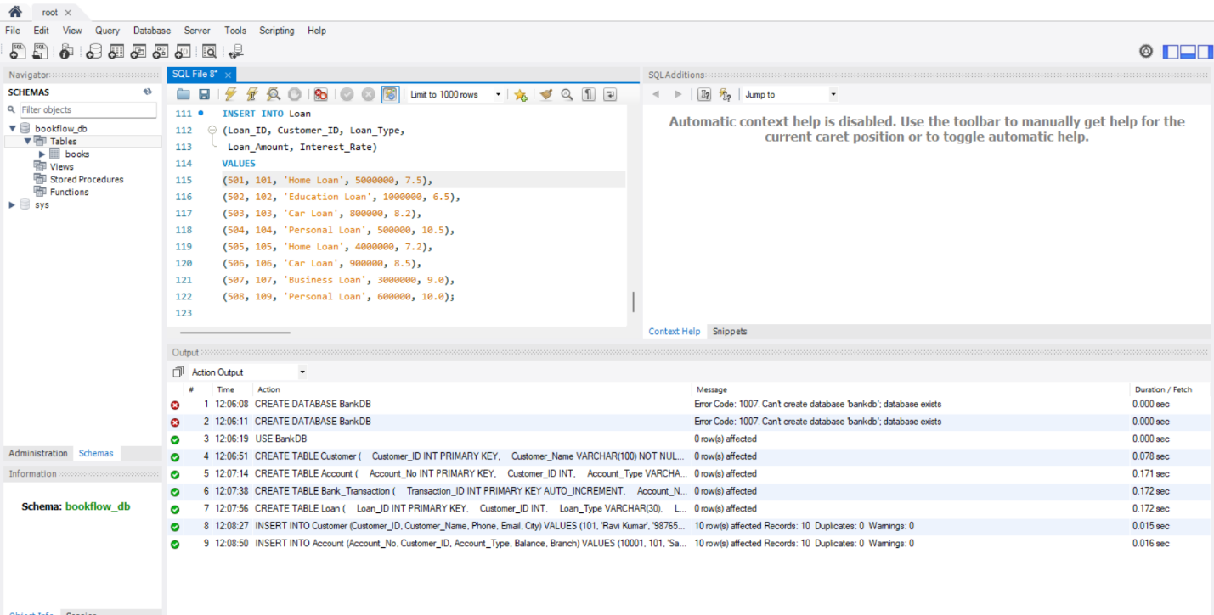 10. DISPLAY ORIGINAL TABLES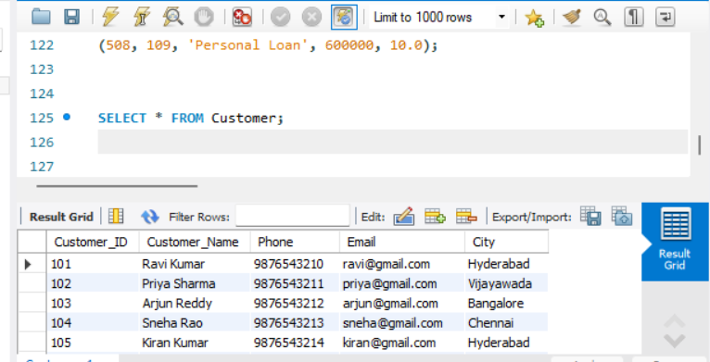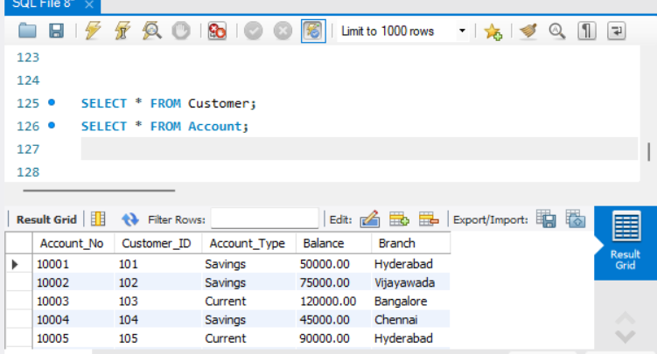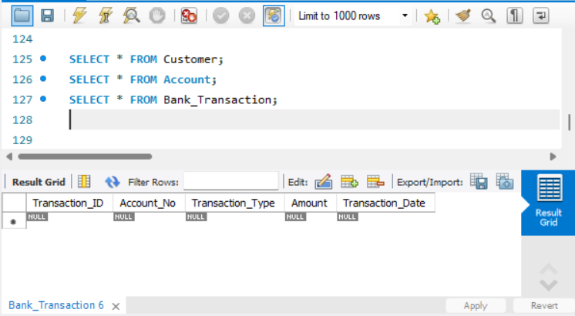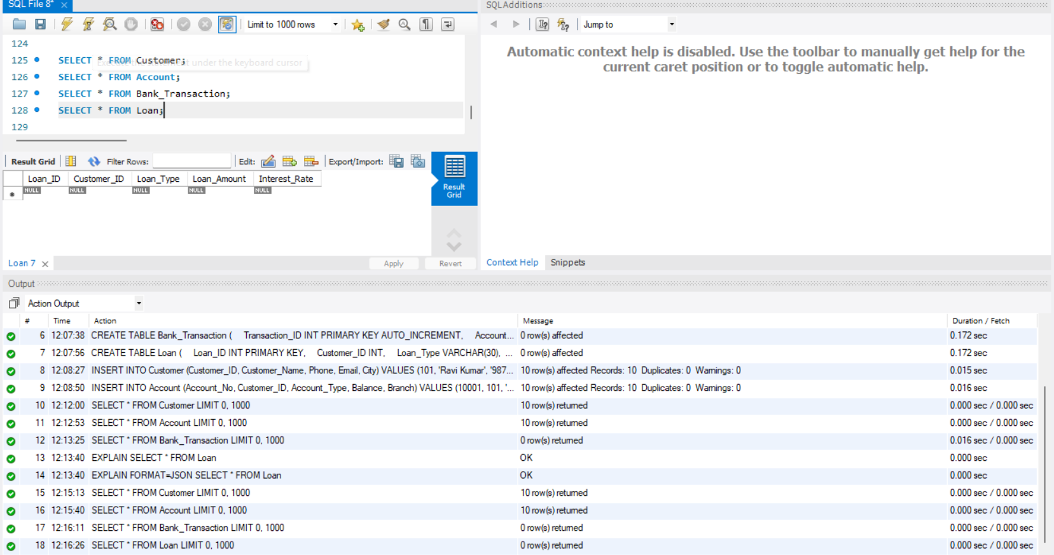12. CREATE A VIEW FOR CUSTOMER BASIC INFORMATION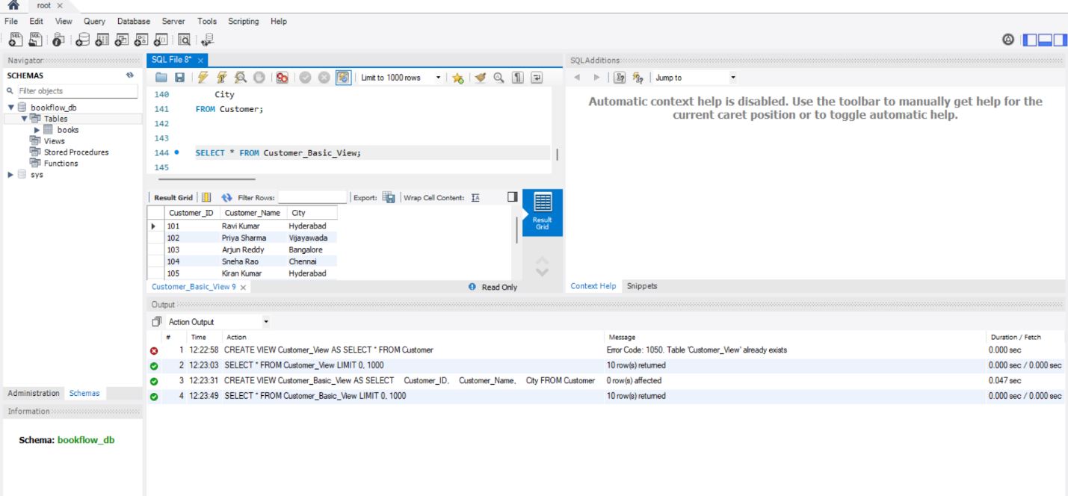14. CREATE A VIEW FOR SAVINGS ACCOUNTS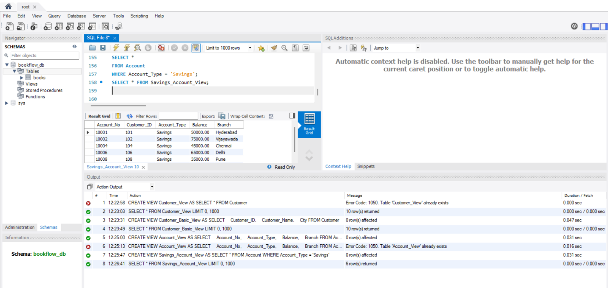15. CREATE A VIEW FOR CURRENT ACCOUNTS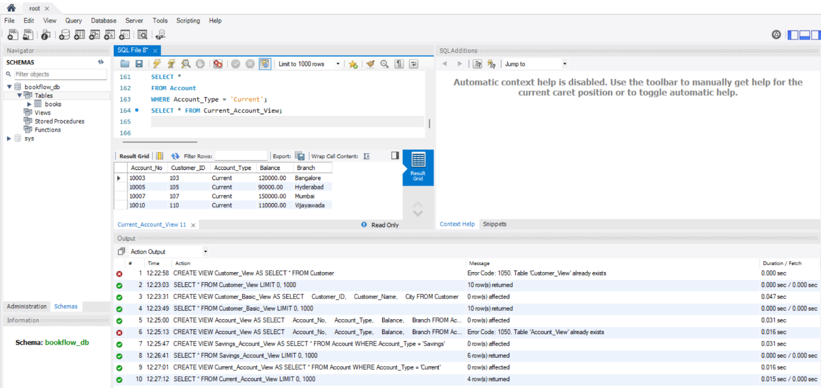17. HYDERABAD ACCOUNT VIEW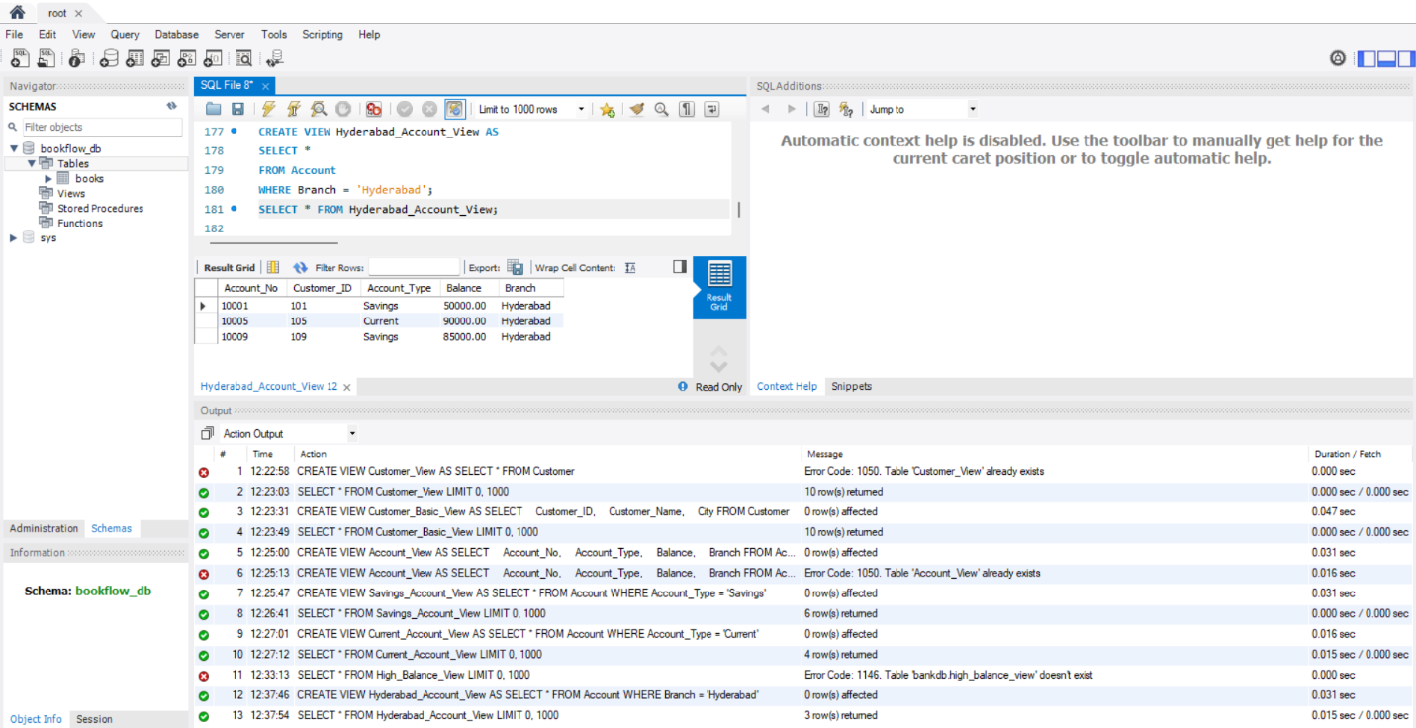18. LOW BALANCE ACCOUNT VIEW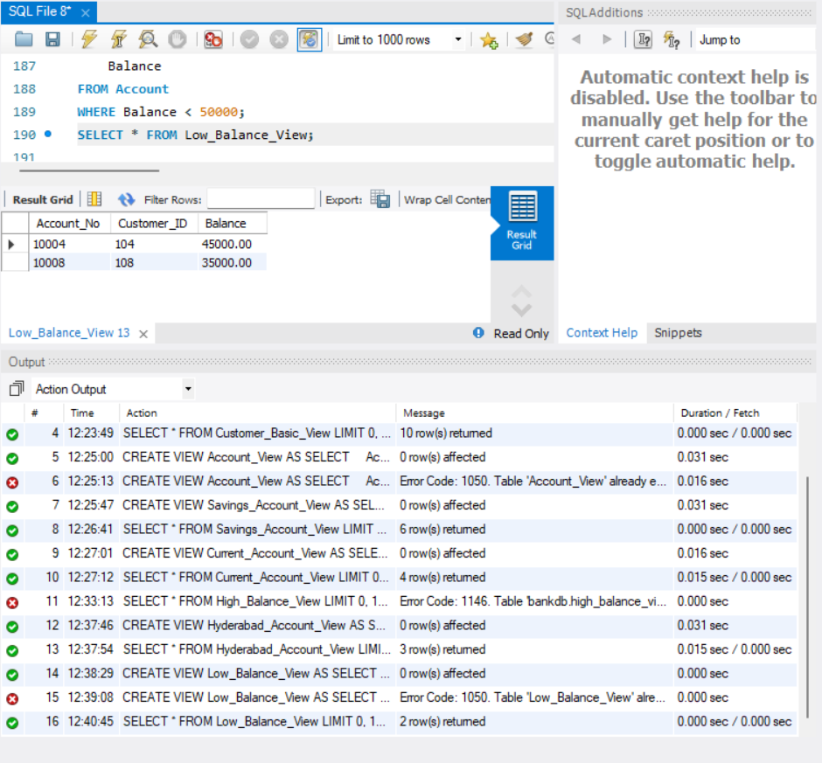19. CUSTOMER + ACCOUNT VIEW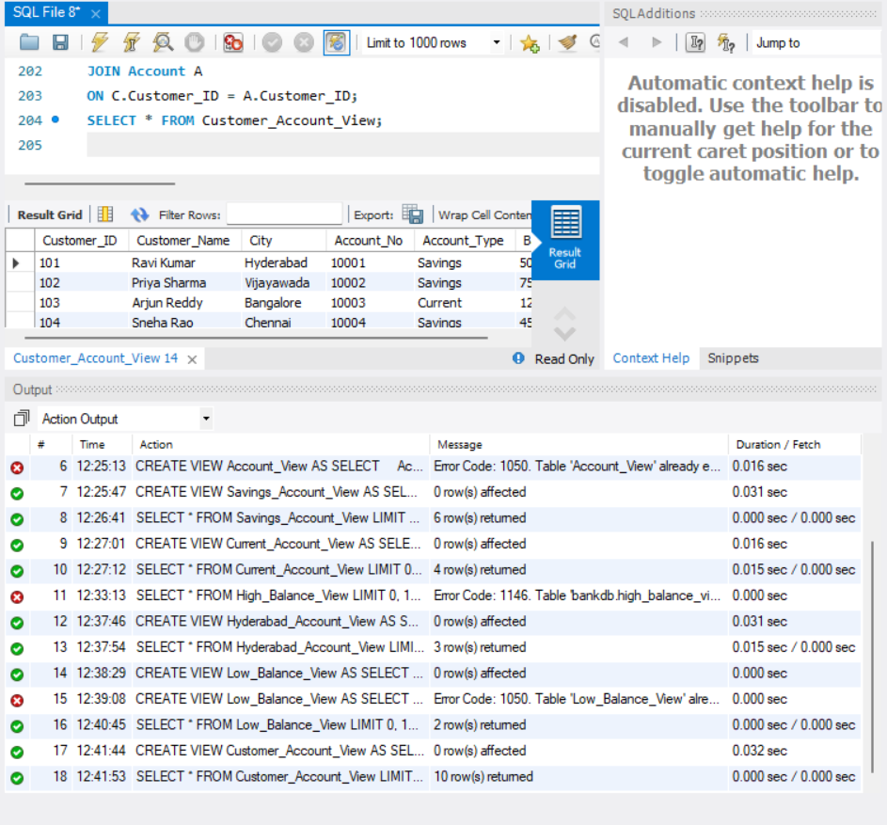20. HYDERABAD CUSTOMER ACCOUNT VIEW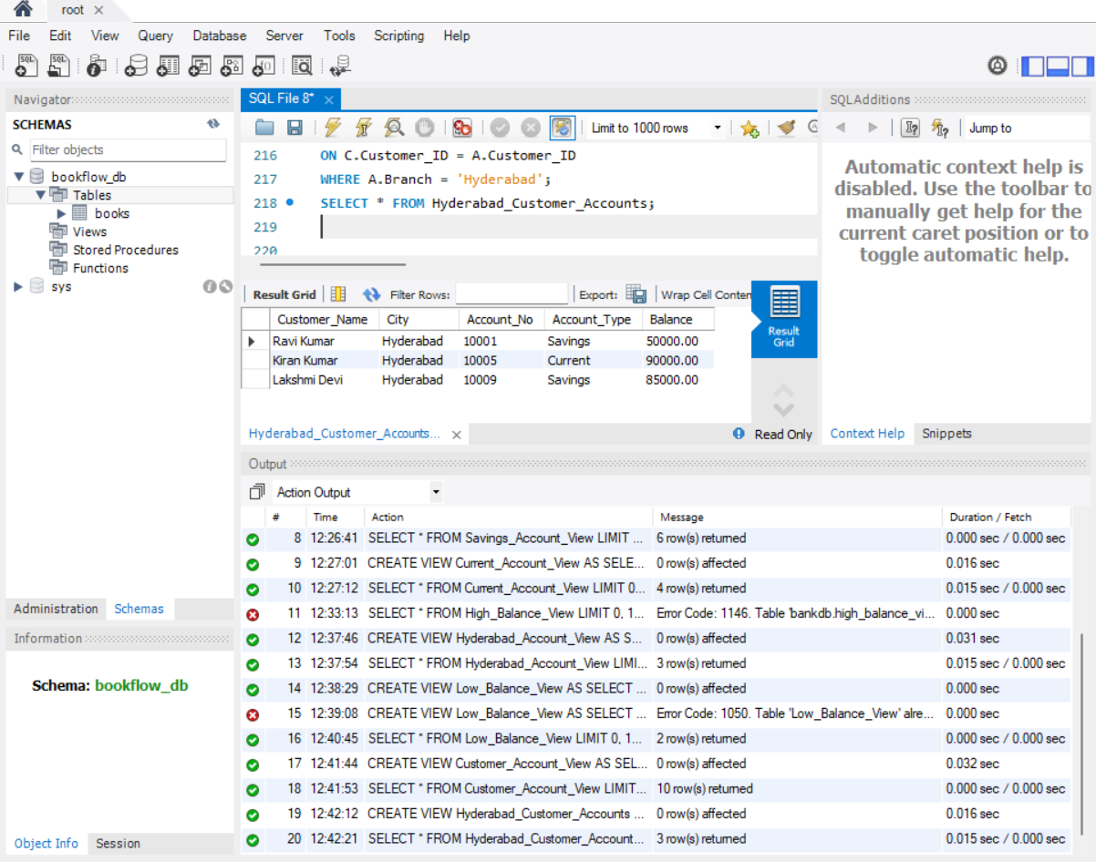21. CUSTOMER LOAN VIEW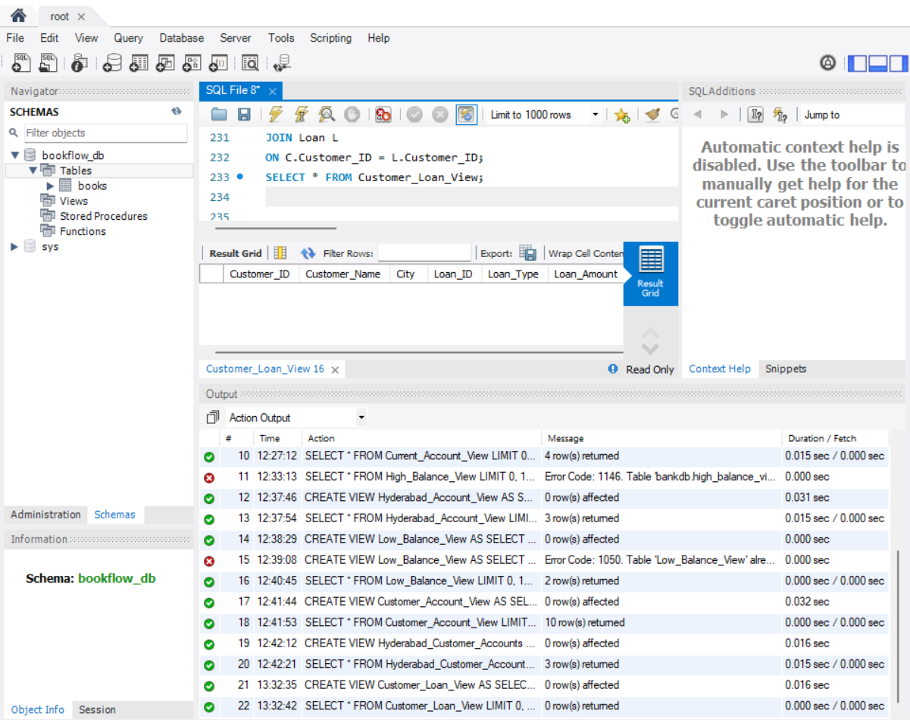22. COMPLETE CUSTOMER BANKING VIEW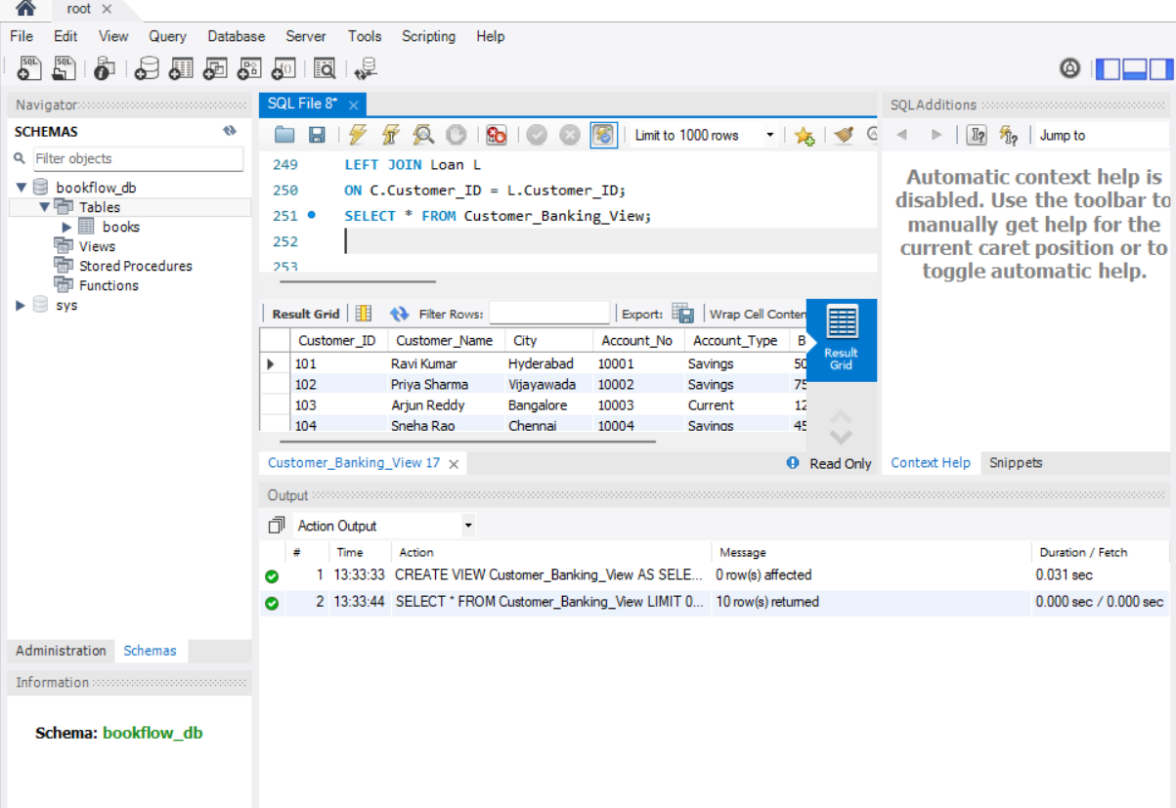23. TOTAL BANK BALANCE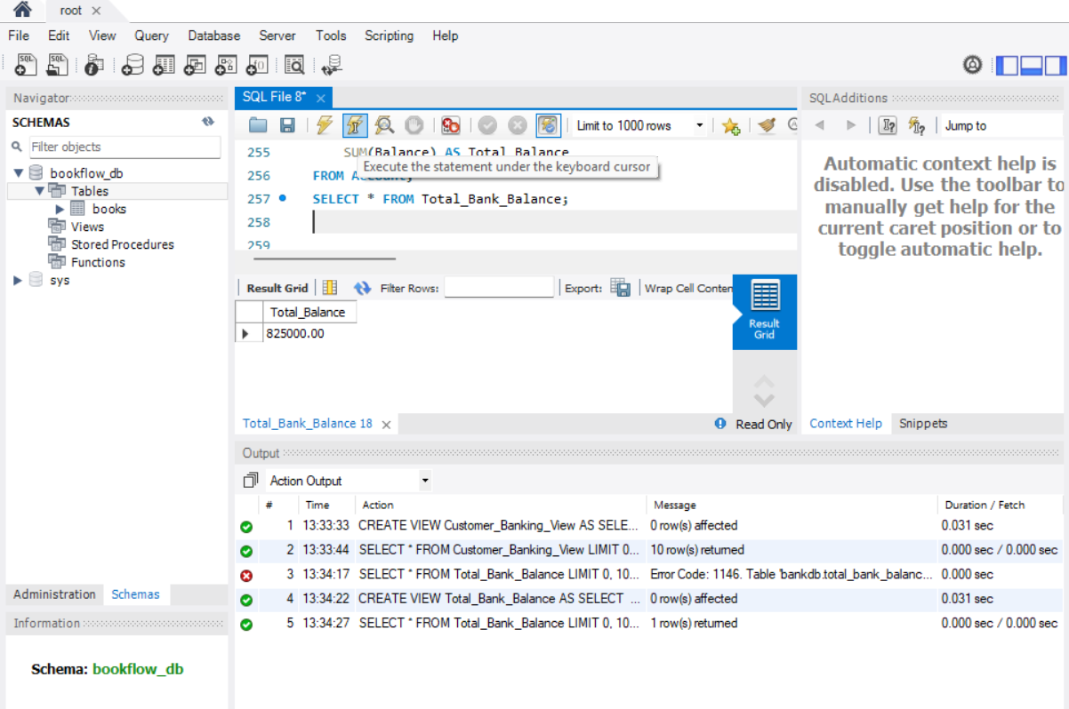24. AVERAGE ACCOUNT BALANCE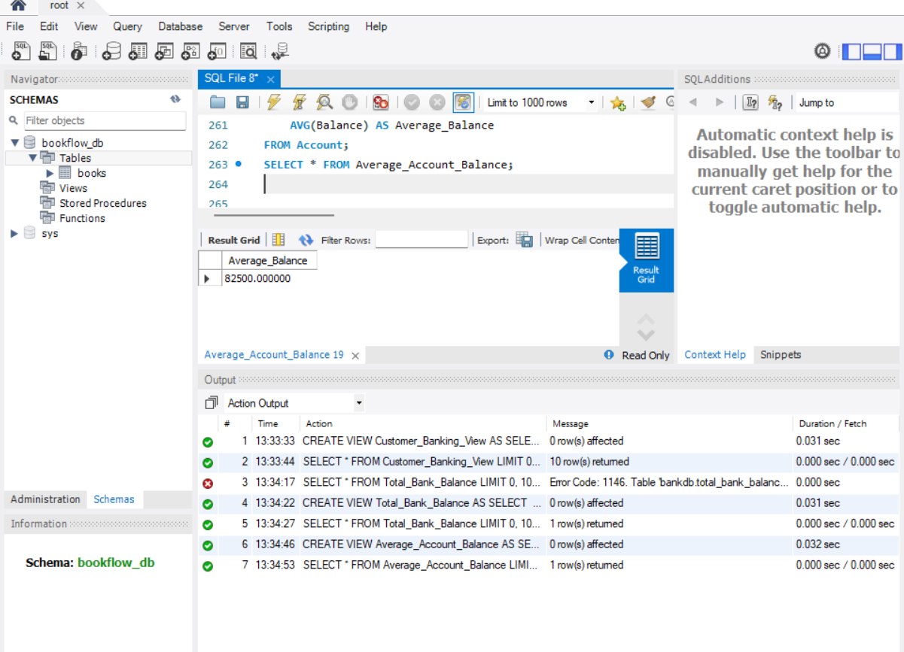25. MAXIMUM ACCOUNT BALANCE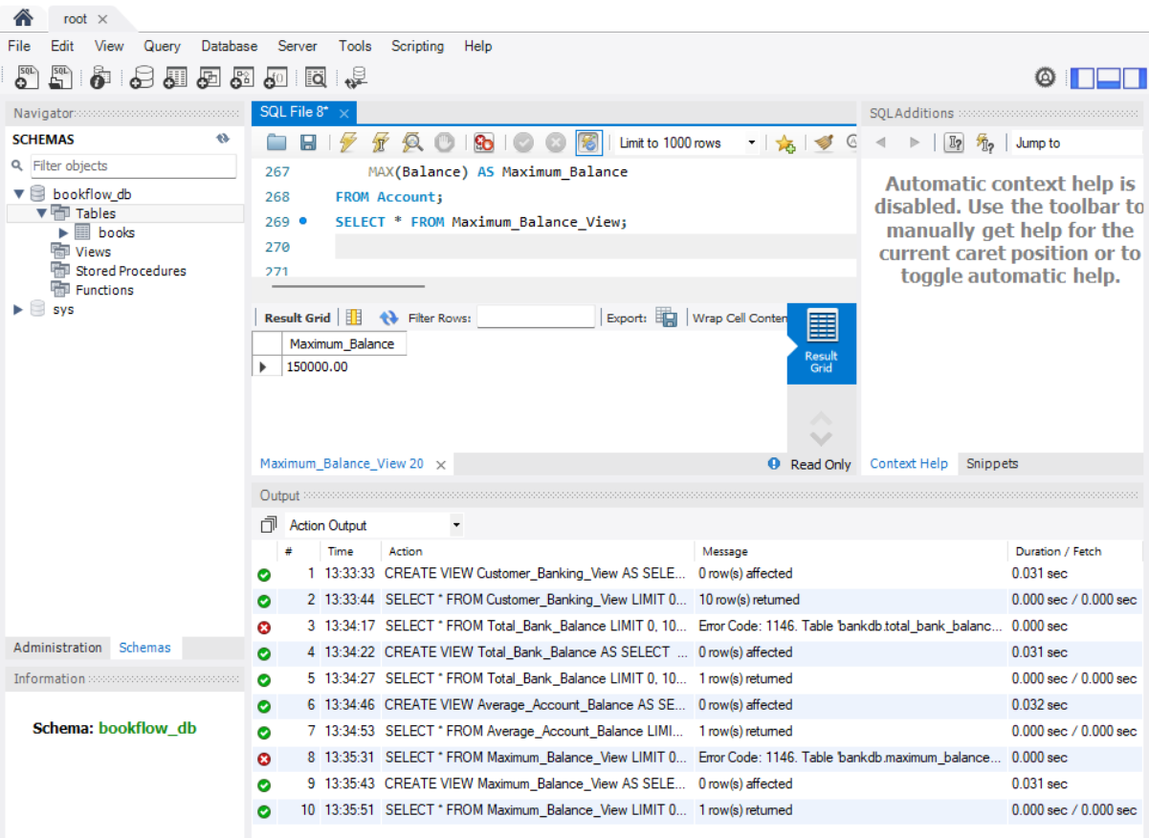26. MINIMUM ACCOUNT BALANCE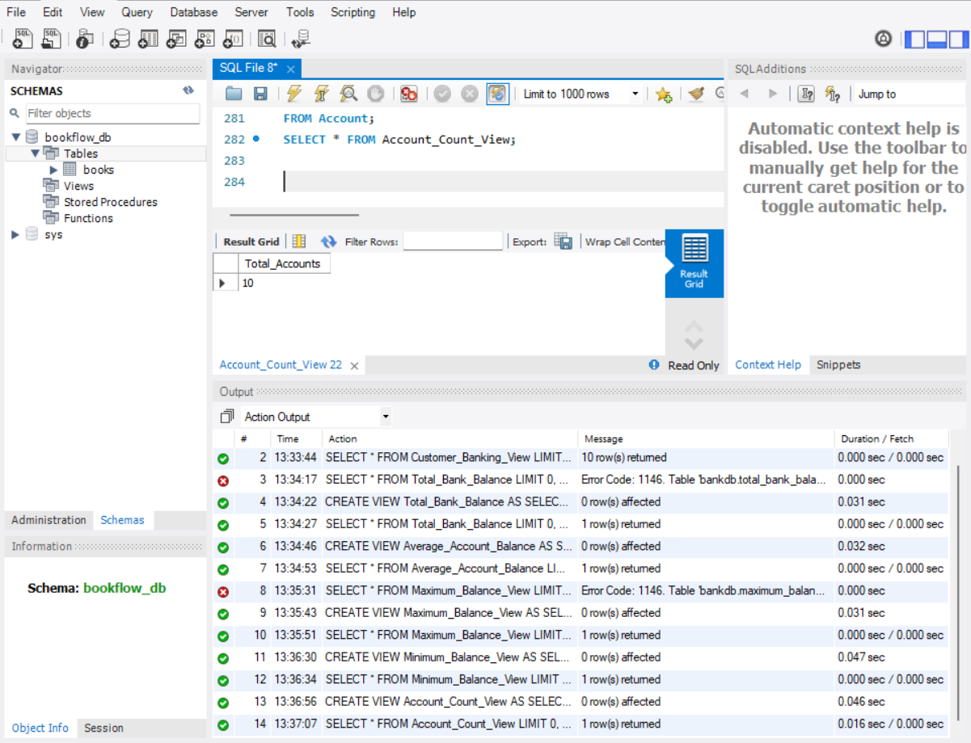28. BRANCH-WISE ACCOUNT COUNT 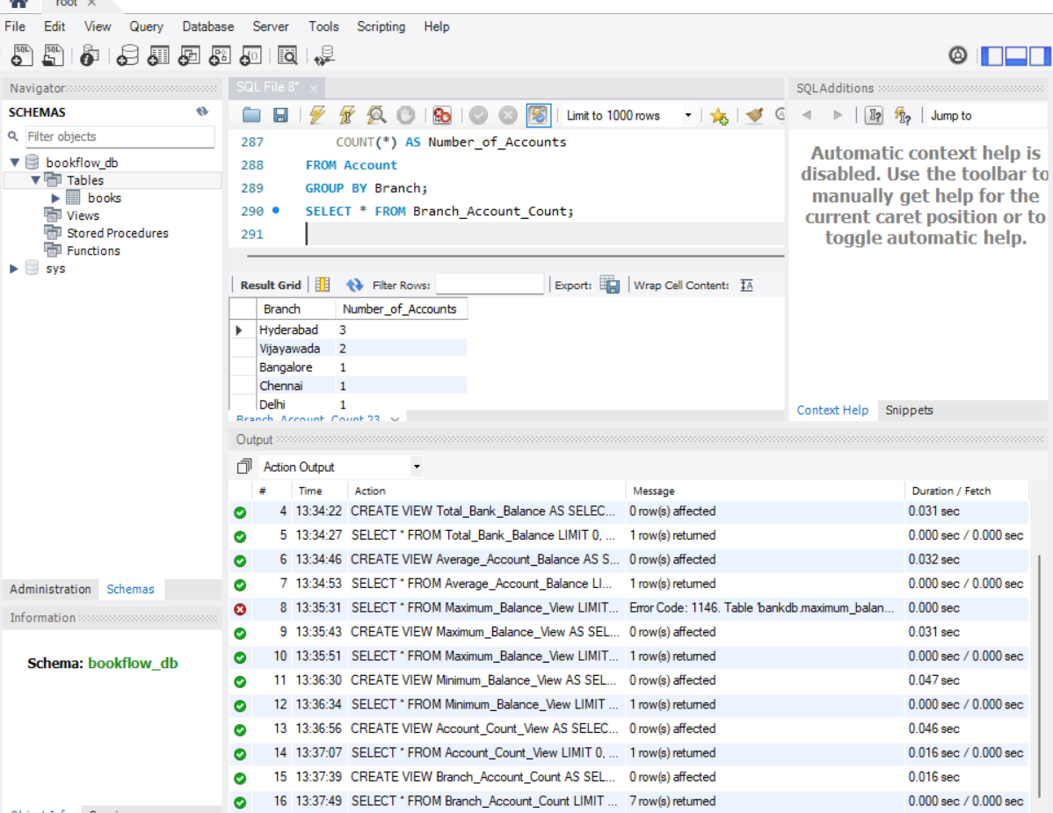29. BRANCH-WISE TOTAL BALANCE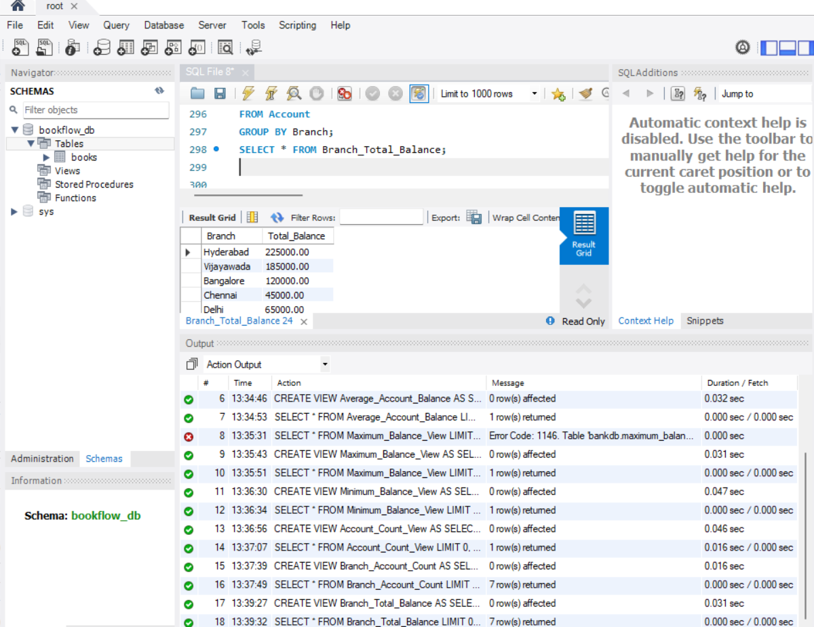30. ACCOUNT TYPE COUNT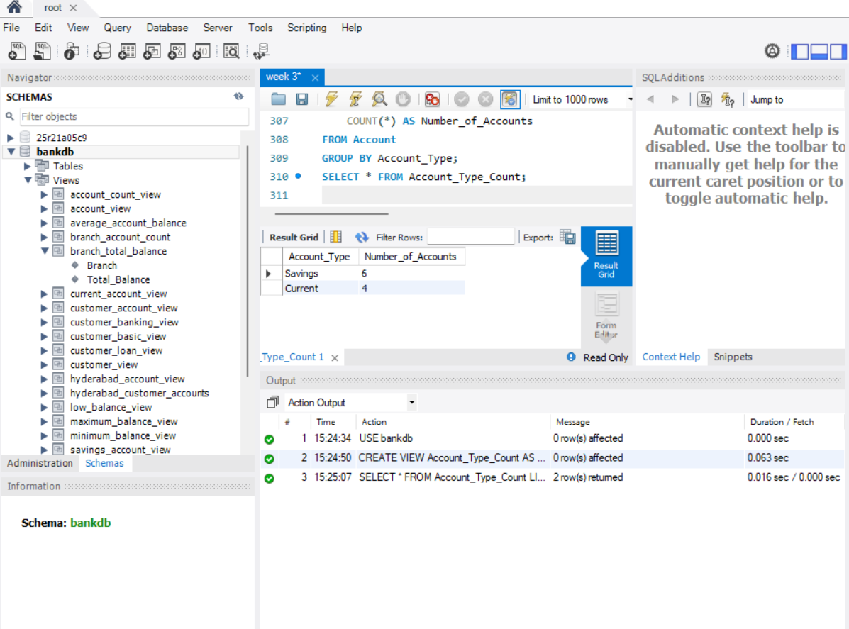31. ACCOUNT TYPE TOTAL BALANCE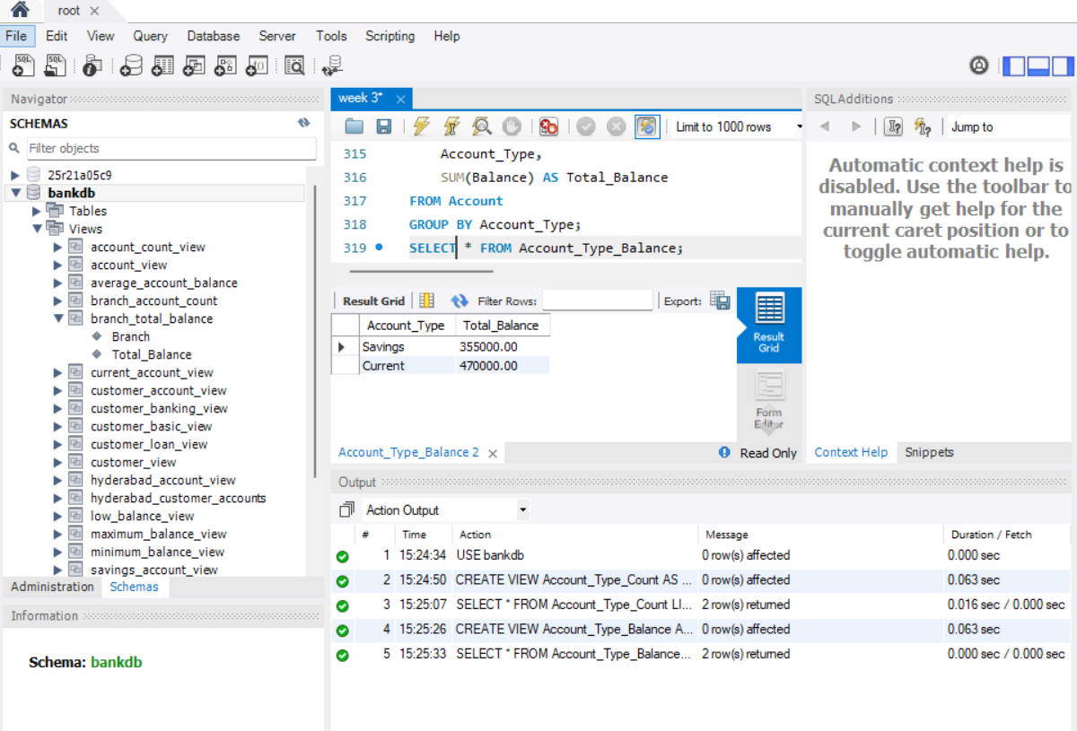32. BRANCHES WITH MORE THAN ONE ACCOUNT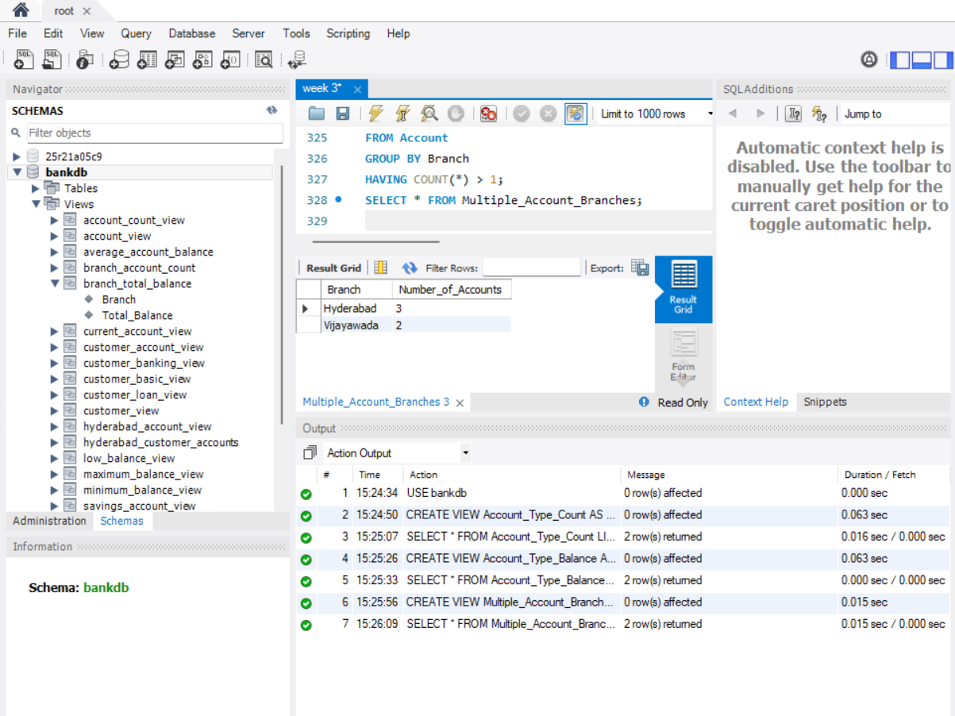33. BRANCHES WITH TOTAL BALANCE ABOVE 100000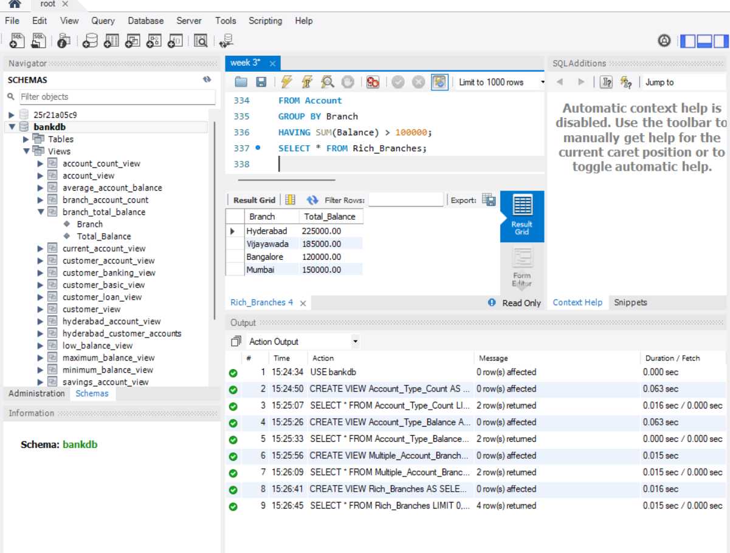34. DEPOSIT TRANSACTION VIEW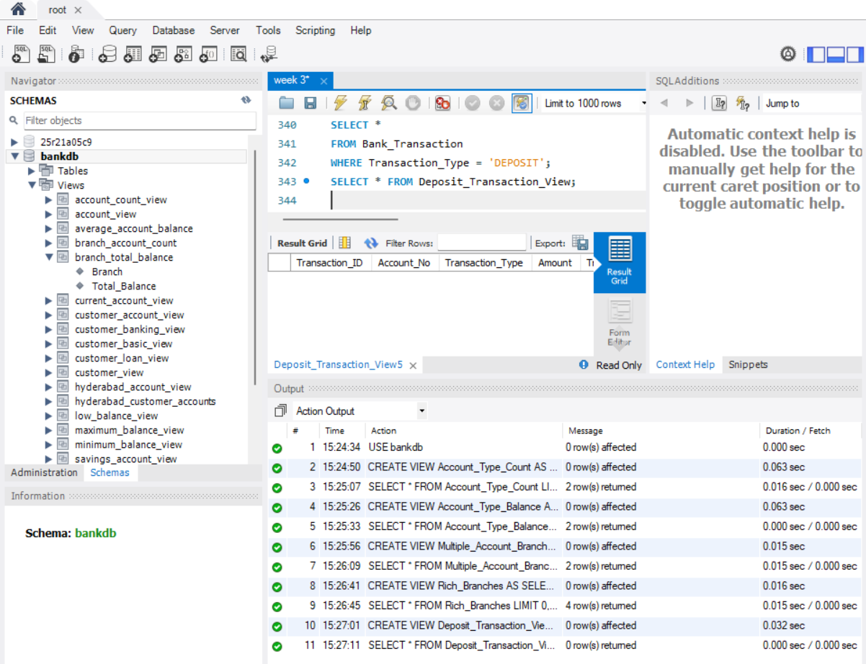35. WITHDRAWAL TRANSACTION VIEW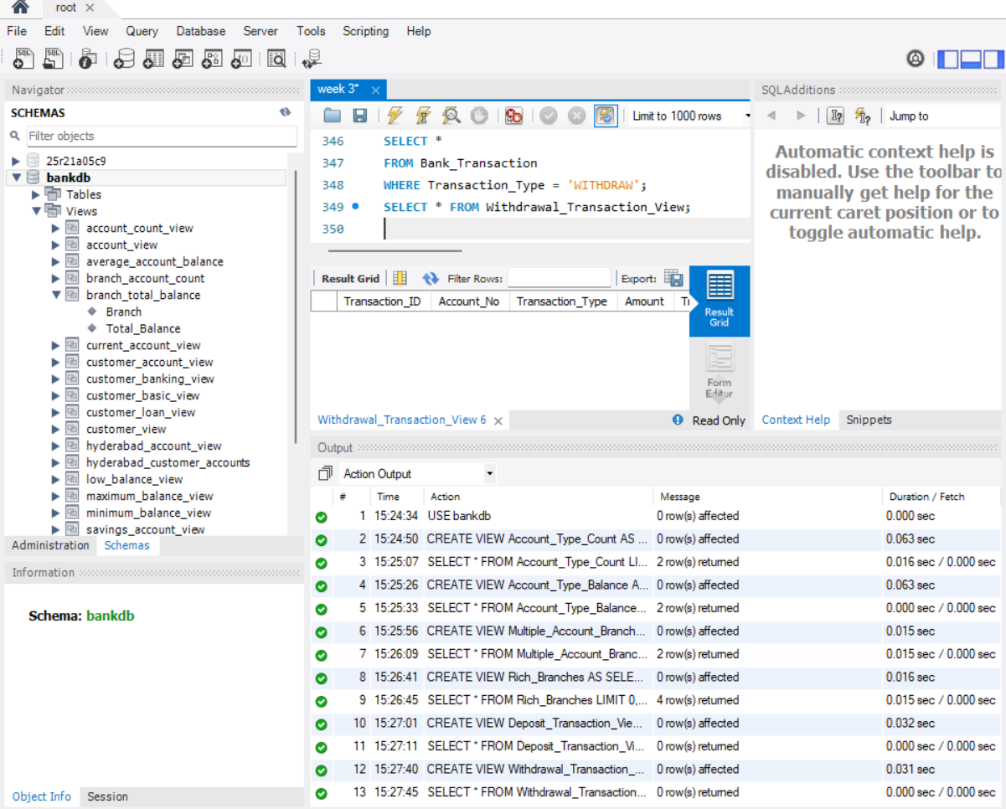36. TRANSACTION DETAILS WITH CUSTOMER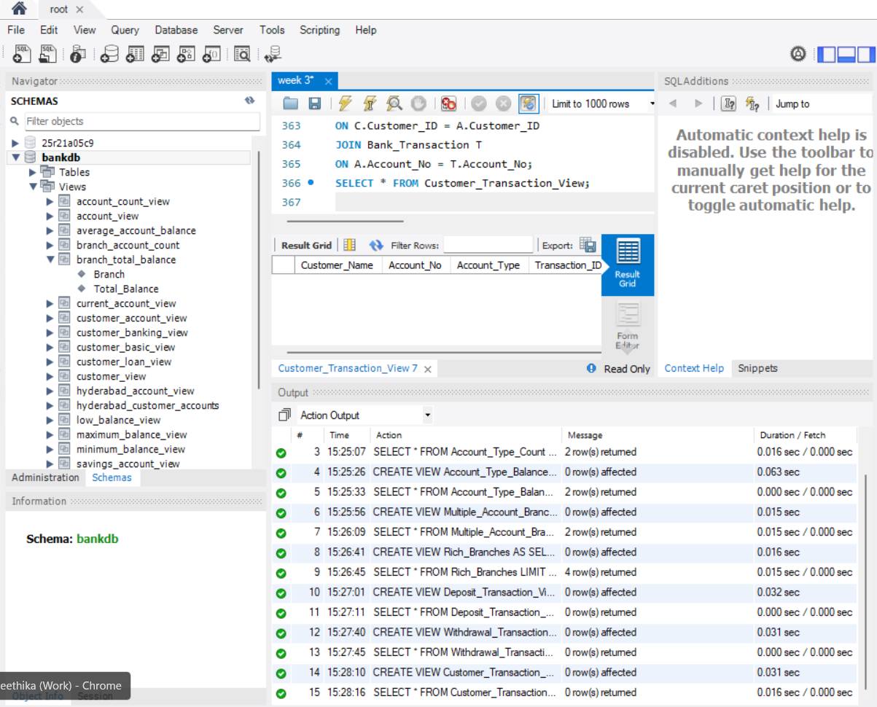37. HIGH VALUE TRANSACTION VIEW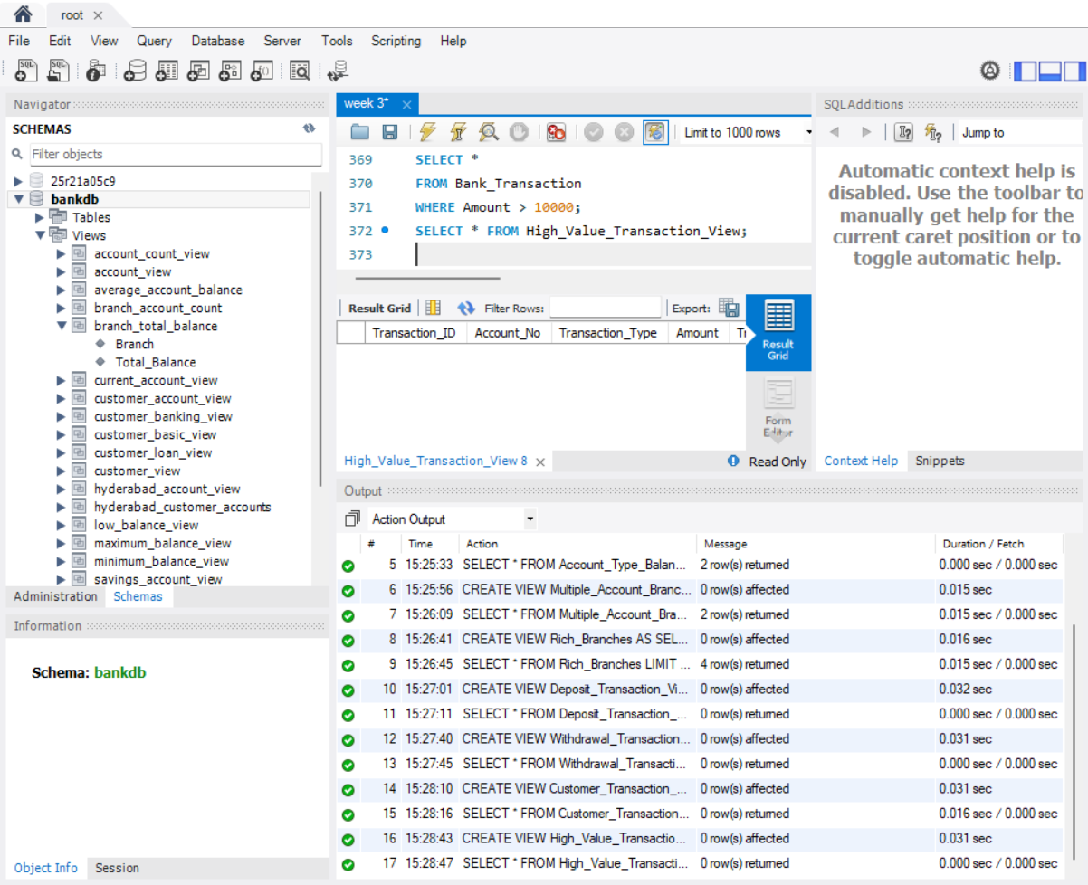38. ACCOUNTS ORDERED BY BALANCE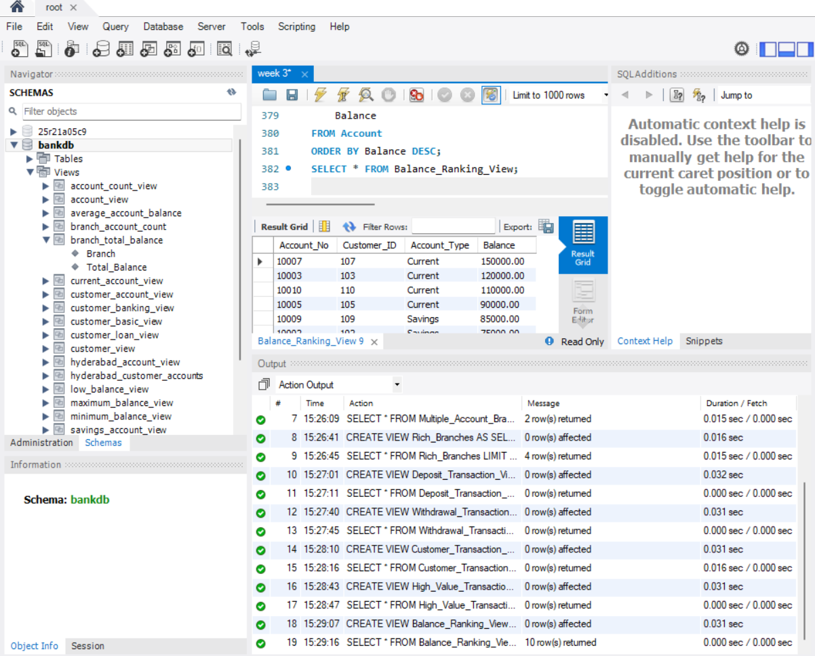39. CUSTOMERS ORDERED BY NAME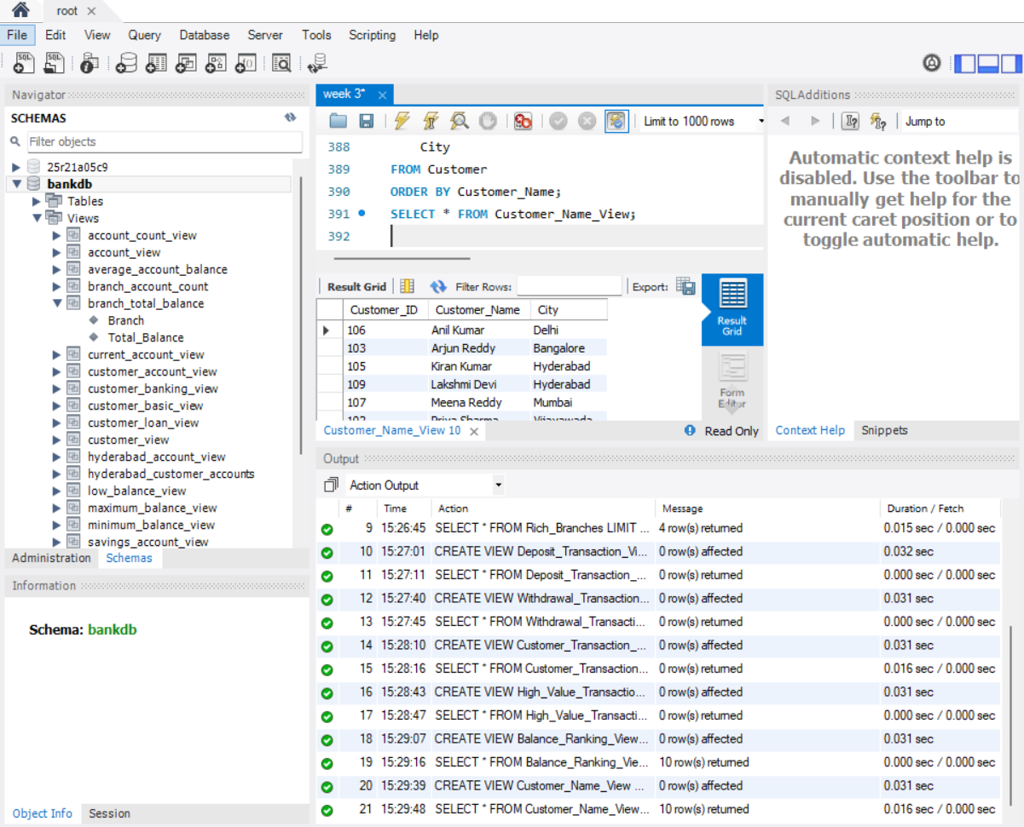40. LOAN INTEREST CALCULATION VIEW 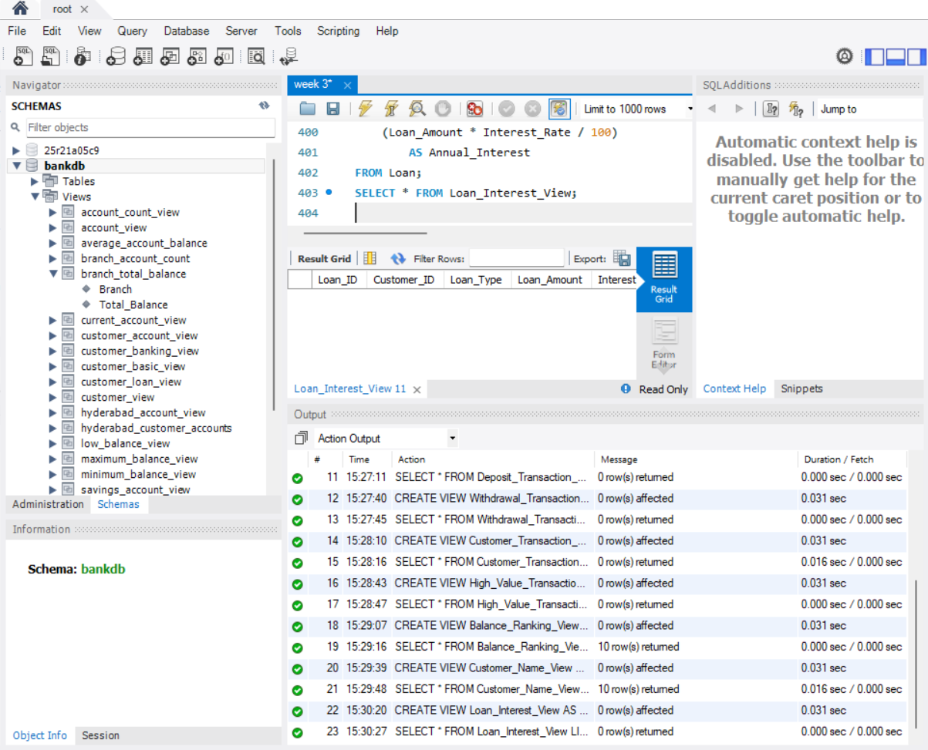41. LOAN TOTAL AMOUNT VIEW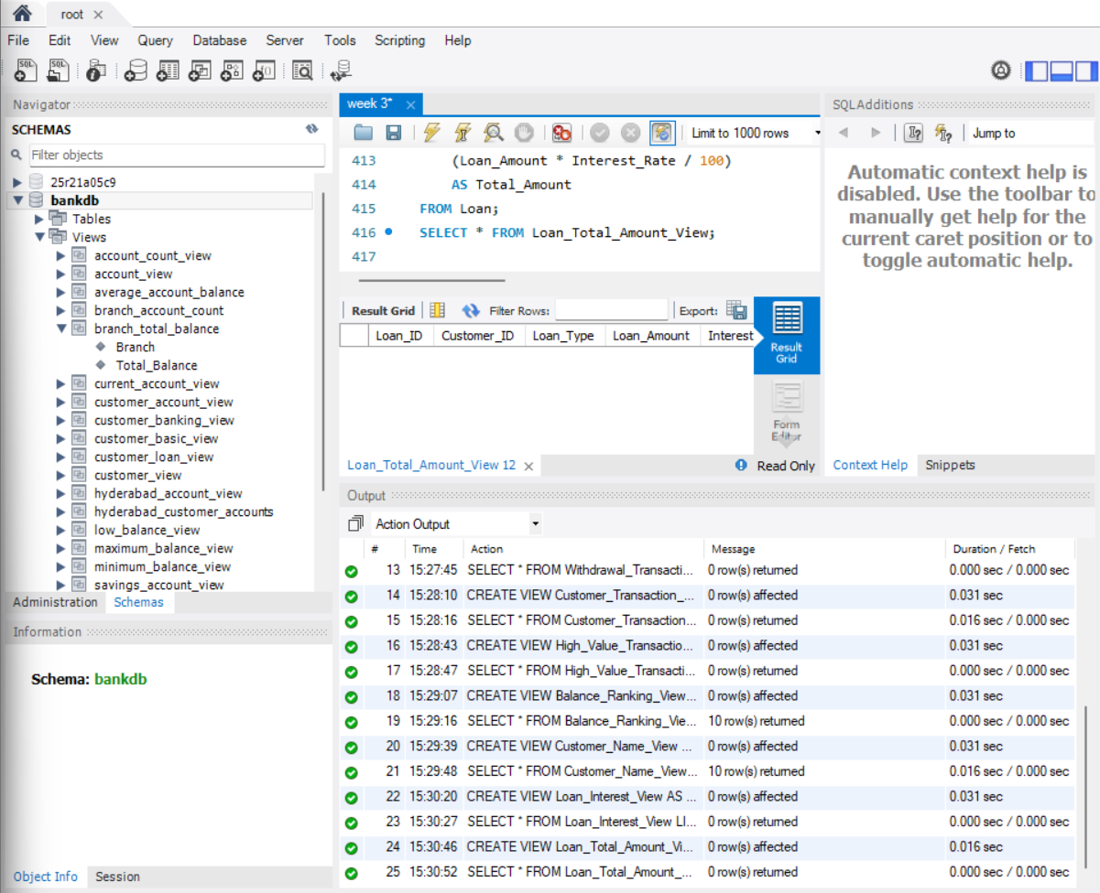42. DISPLAY HIGH BALANCE ACCOUNTS FROM VIEW
43. DISPLAY SAVINGS ACCOUNTS ABOVE 60000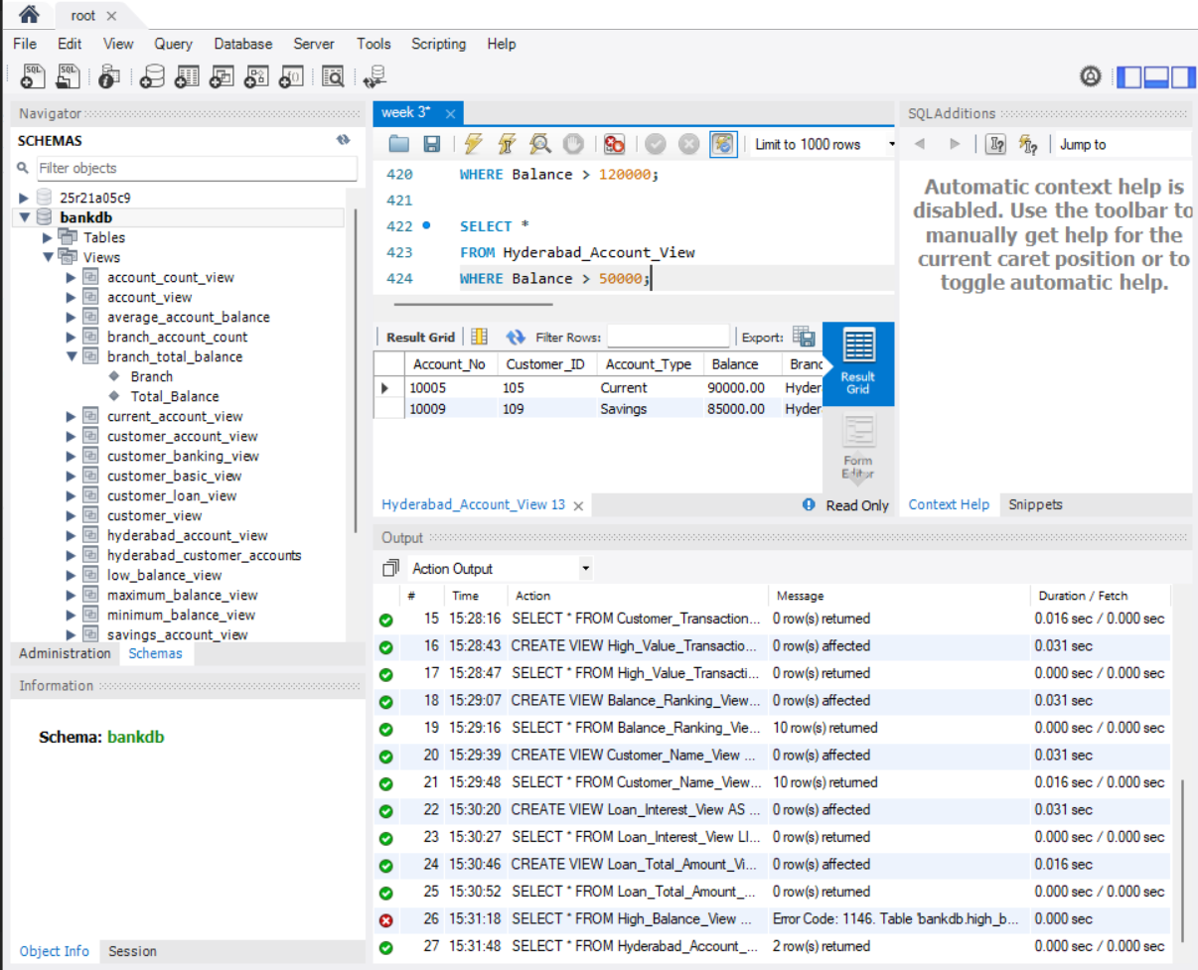45. DISPLAY CUSTOMERS FROM HYDERABAD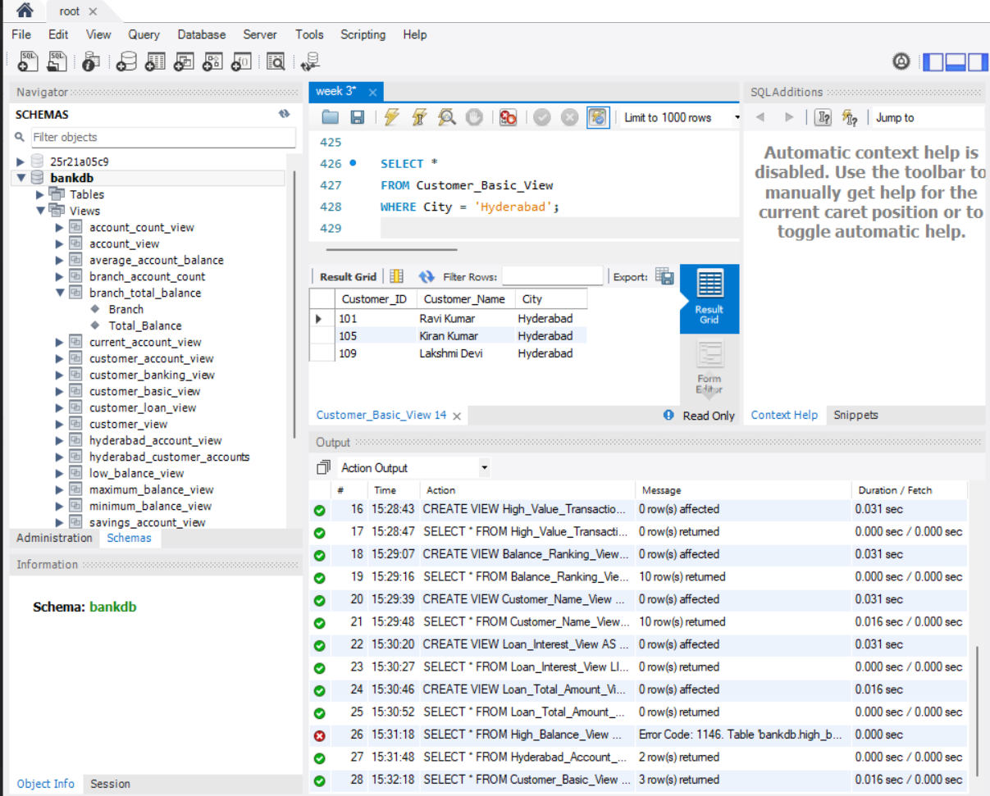46. DISPLAY CUSTOMER ACCOUNTS ORDERED BY BALANCE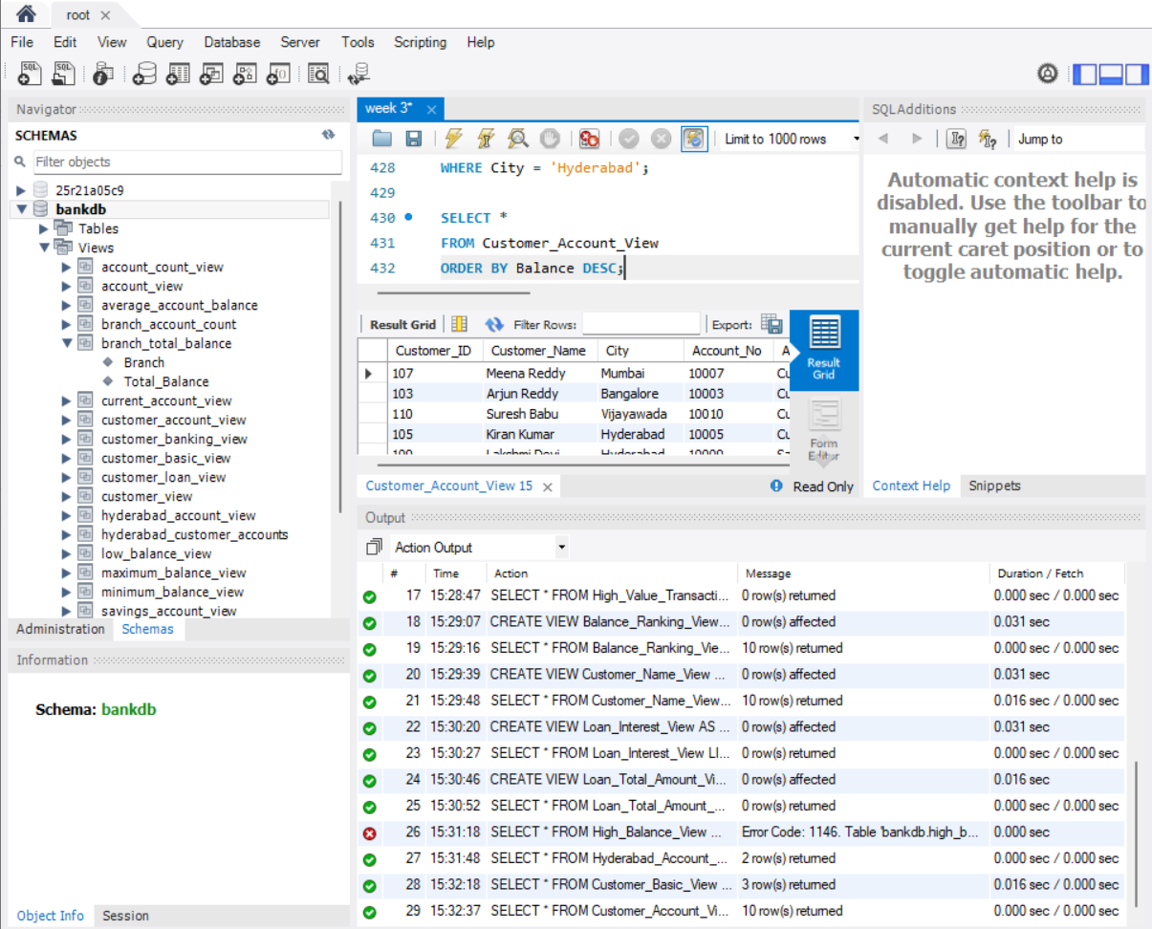47. DISPLAY LOANS ABOVE 1000000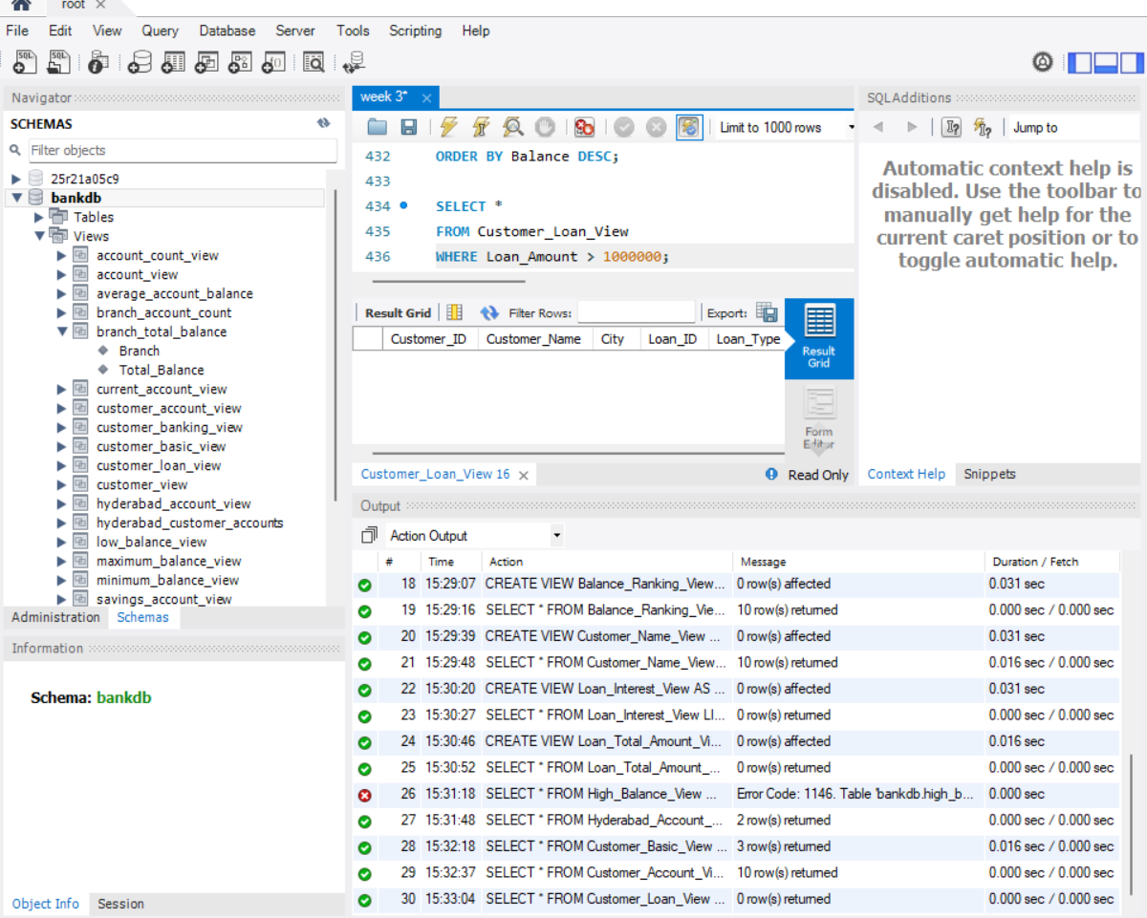48. UPDATE ACCOUNT BALANCE THROUGH VIEW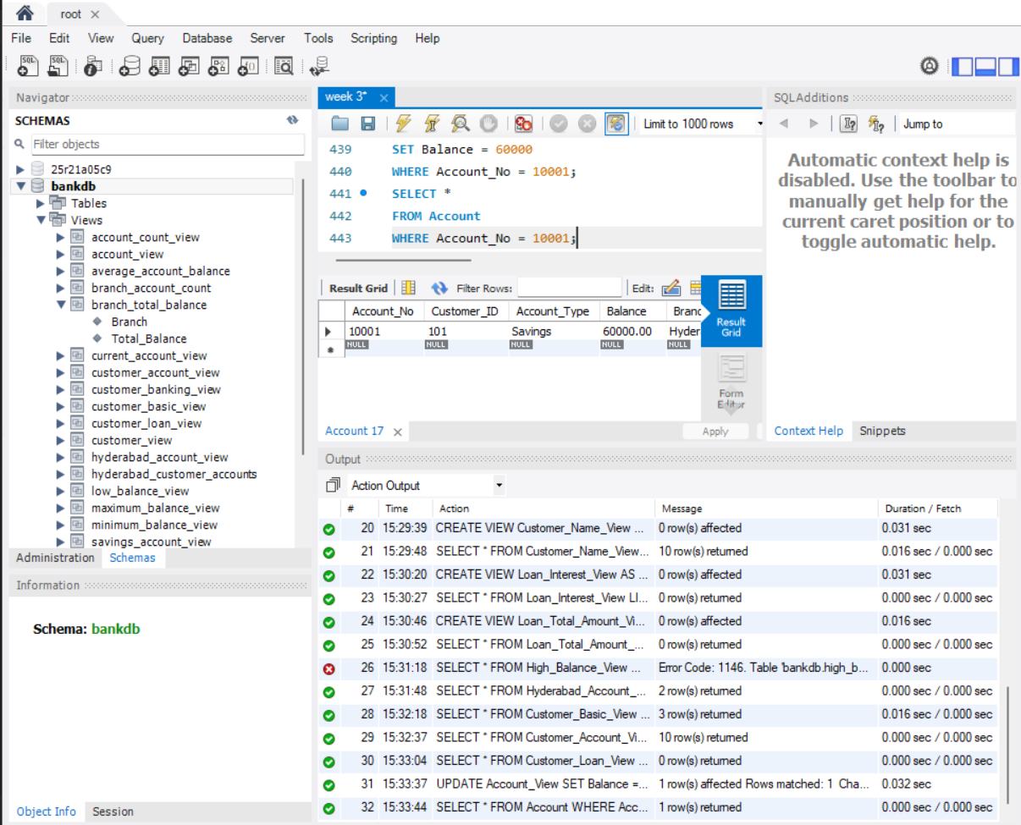49. INSERT USING SIMPLE VIEW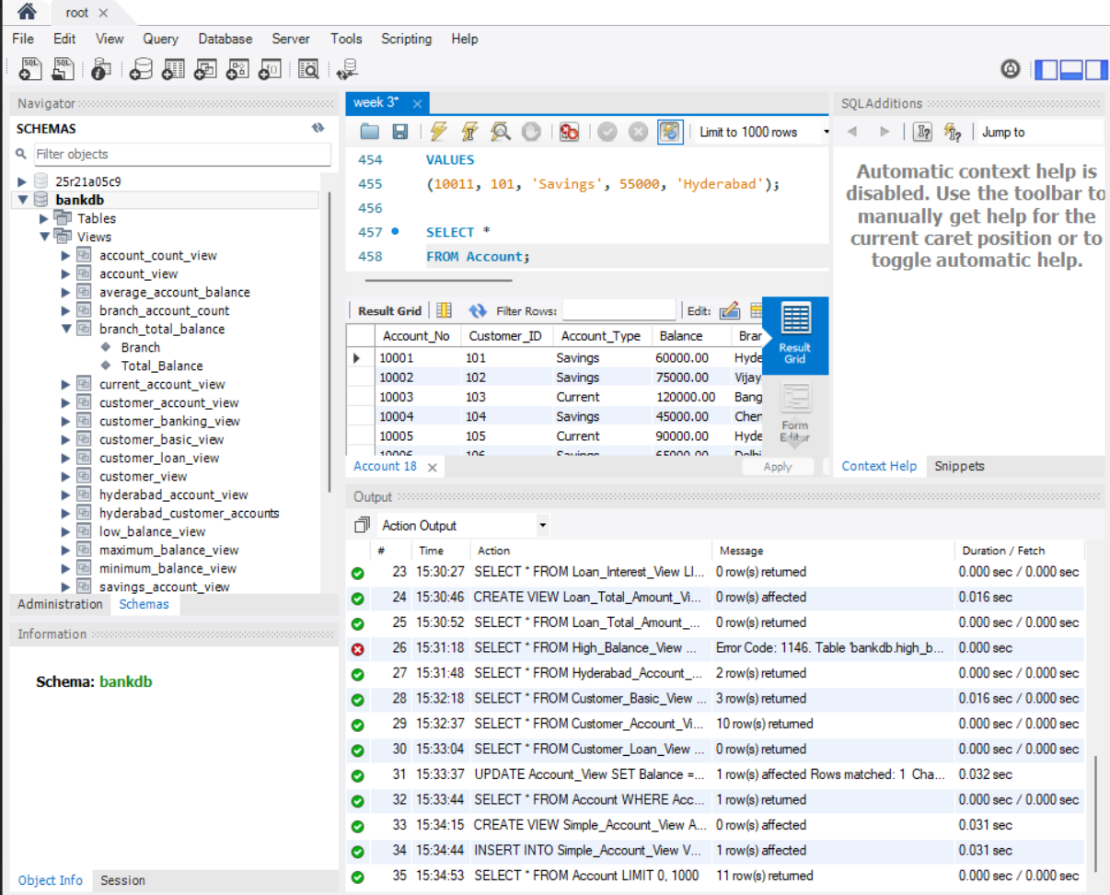50. DELETE USING SIMPLE VIEW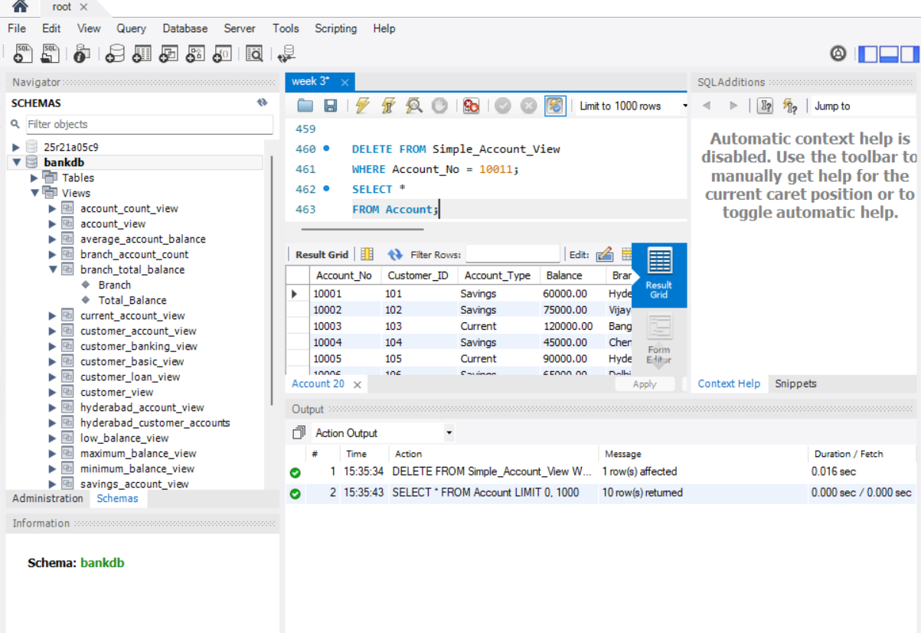51. SHOW ALL VIEWS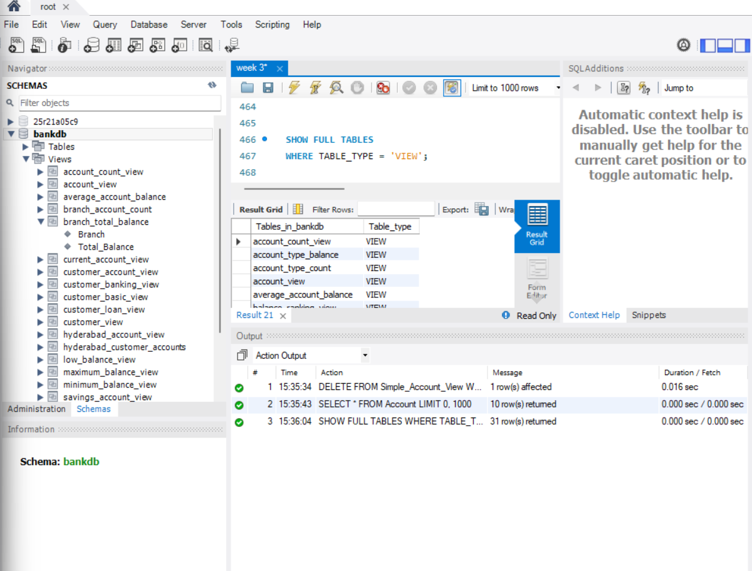52. SHOW VIEW DEFINITION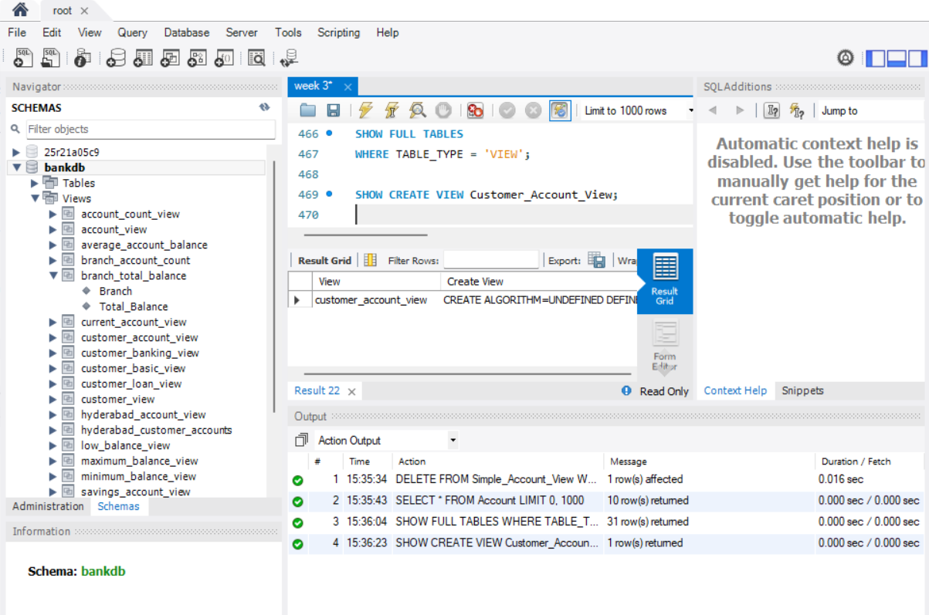53. DESCRIBE VIEW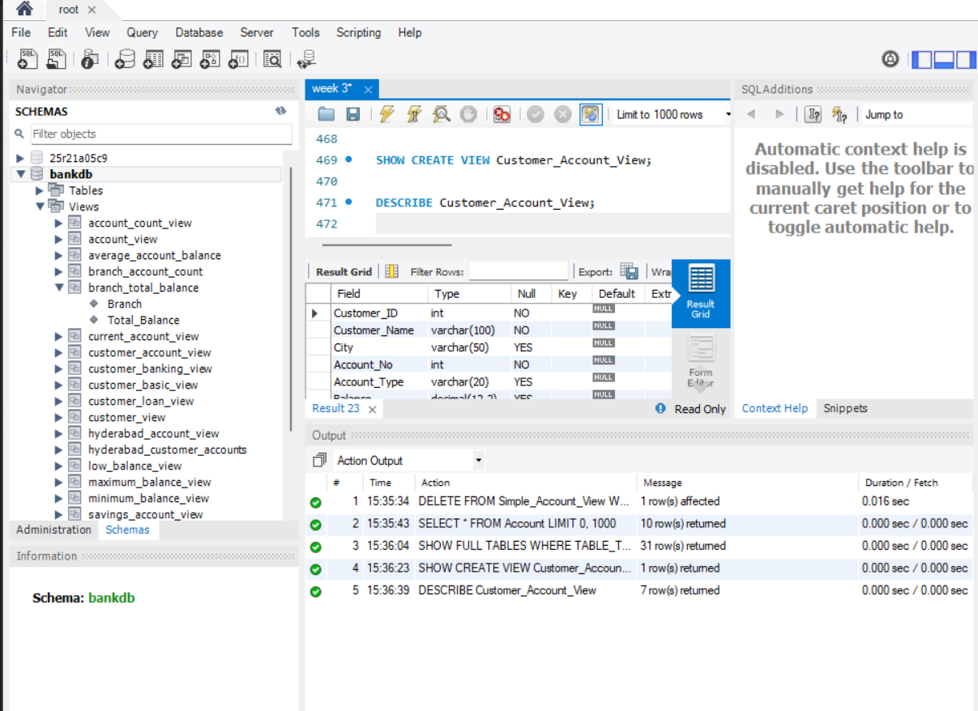54. DROP ONE VIEW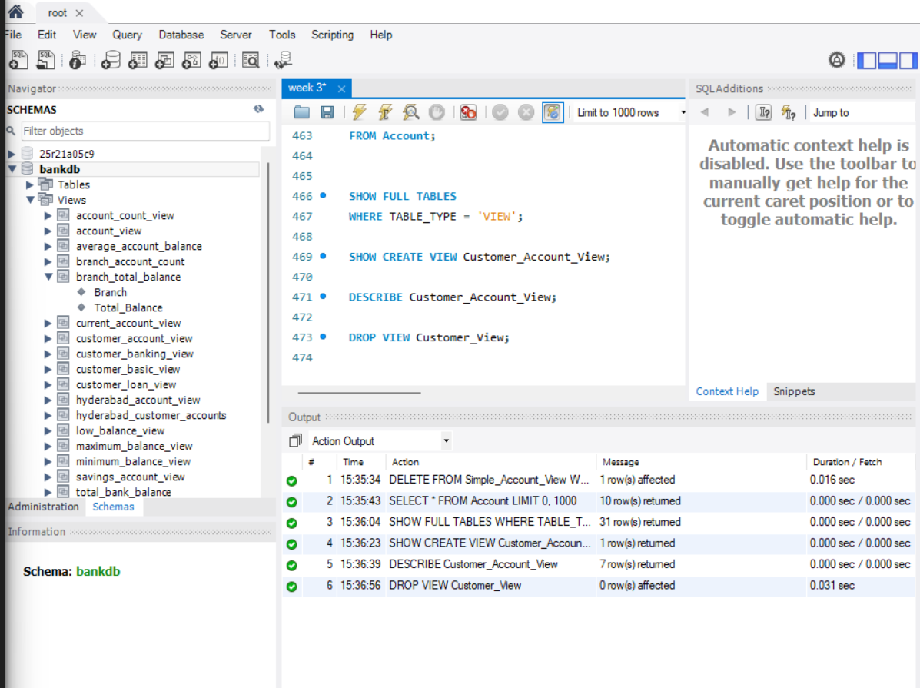55. DROP MULTIPLE VIEWS